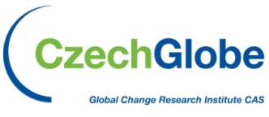
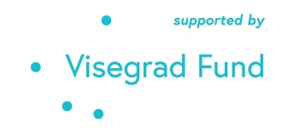
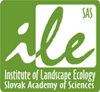
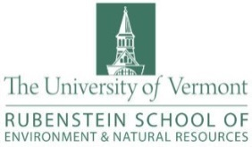
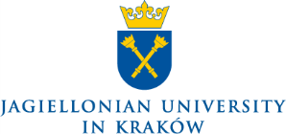
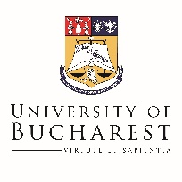
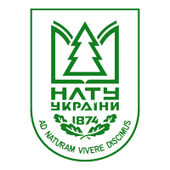
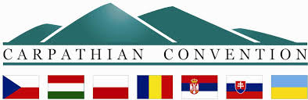

The Global Change Research Institute of the Czech Academy of Science and the Mendel University in Brno in cooperation with
the Science for Carpathians and the Institute of Landscape Ecology of SAS, the Centre for Ecological Research in Budapest, the University of Vermont, the Pedagogical University of Krakow, the Jagiellonian University in Krakow, the Ivan Franko National University of Lviv, the University of Bucharest, and the Ukrainian National Forestry University cordially invite your participation in:

An international scientific conference
6th FORUM CARPATICUM - Linking the Environmental, Political and Societal Aspects for Carpathian Sustainability

Conference websites http://forumcarpaticum.czechglobe.cz/

1st Announcement
The Forum Carpaticum is an open meeting of the Science for the Carpathians (S4C) initiative. S4C – Science for the Carpathians – connects scientists in Central Europe, defines research priorities for the region, provides applicable findings for the politics of the region and enhances international collaboration with partners from outside the Carpathians.

Conference Venue
The conference will be held from 22nd June to 26th June, 2020, in the Conference centre of Mendel University in Brno, Czech Republic.

Conference goals
- Push the forefront of Carpathian research on climate, ecological processes, nature conservation, sustainable use of natural resources, human-environment interactions, education for sustainable development

- Provide researchers and stakeholders with a space for exchanging ideas and research results, fostering dialogue between research, policy and practice to make the Carpathians more sustainable

- Promote new inter-disciplinary and trans-disciplinary collaborations, establish links between S4C, local and regional authorities and various stakeholders involved in environmental management

Conference topics (including, but not restricted to)
- Assessment of climate change vulnerabilities of forest and agricultural sectors and their dependency from adaptation opportunities and climate change mitigation.
- How can the concepts of Bio & Circular-Economy contribute to the sustainable use of natural resources in the Carpathians?
- Can biodiversity loss effect the sufficient provision of ecosystem services in the Carpathians?
- Rural urban relationships, connectivity of urban greenness with the peripheral zones
- Conservation science and practical policy measures to promote the sustainable transformation process of the Carpathians
- Carpathian waters
- Advances in earth observations for sustainable development
- Traditional land management, rural development, smart & sustainable planing , social innovation, sustainable tourism development
- Historical human-environment interactions in the Carpathians, damages from environmental crime and their contemporary effects;
- Spatial justice, services of general interest and governance
- Education for the sustainable Carpathians - the milestone for the present and future of the Carpathians
Call for Sessions and Workshops
Participants are invited to submit proposals for sessions or workshops in line with the conference goals and topics, containing the title, short description of your introduction lecture. Session and workshops will last for two hours and the sessions will include up to six oral presentations. Select sessions or their parts can be devoted to alternative forms of presentation, such as flash talks. It is recommended to devote sufficient time to the discussion.

Call for Papers
Participants are invited to submit abstracts of papers and posters related to the themes of the Conference. The abstract must be written in English. To submit an abstract please follow this procedure and make use of the template on last page of 1st announcement.

Instructions for Presenters
The maximal number of presentations per registered participant is 1 oral + 1 poster. We expect that for oral presentations the allotted time will be 15 minutes maximum + 5 minutes for discussion. In case of flash talks, speakers will have 3 minutes in total.
Please prepare your presentation in .ppt, .pptx (Microsoft Office PowerPoint 2003-2017 format) or .pdf file in advance of the conference. Please note that using your own notebook is not recommended.
A flash talk is a short presentation lasting only three minutes, including two slides in which speakers present a scientific concept or idea in a manner understandable across a range of disciplines, while also encouraging the audience to visit the poster session.
Posters should be prepared for standard STANDING (PORTRAIT) A/0 size (84 x 119 cm – 1 sqm).

Publication options
Abstract Proceedings will be provided to the participants on the conference website. The Organizing Committee will try to find the appropriate publishing opportunities for all oral presentations and posters in special issues of scientific journals (e.g. MDPI journals as the Sustainability with link https://www.mdpi.com/journal/sustainability).

Official language of the conference will be English.

Preliminary Programme
22nd June 2020 Seminars with stakeholders
23rd June 2020 Conference
24th June 2020 Conference
25th June 2020 Excursion, Gala dinner
26th June 2020 Conference

Time Frame
9th January 2020 Registration, session proposals and abstract submission opens
9th February 2020 Session proposals deadline
7th March 2020 Abstract submission deadline
5th April 2020 Notification of abstract acceptance and announcement about oral and poster presentations
30th April 2020 Early bird registration fee deadline
30th May 2020 Standard registration fee deadline
19th June 2020 Latest Registration deadline and higher registration fee deadline

Registration and Accommodation
Total registration fee includes rent of conference rooms, registration kit, coffees and lunches during conference, gala dinner and field trip.
 | Full registration fee | Student`s registration fee
Early bird registration fee | 120 EUR | 60 EUR
Standard registration fee | 145 EUR | 100 EUR
Late registration fee | 170 EUR | 120 EUR

Near the conference venue in Brno there are many accommodation options. Therefore, conference participants are asked to reserve accommodations for themselves. The list of some recommended hotels and hostels will be provided on the conference websites http://forumcarpaticum.czechglobe.cz/.

Cancellation fees:
Until 30th April 2020 - 10% of conference fee
Until 12th June 2020 - 50% of conference fee
After 12th June 2020 - 100% of conference fee

Payment
All payments should be made in EUR. All charges due to bank transfers have to be paid by the sender.
Bank transfer data will be specified in second announcement and on web site of conference.
In exceptional cases (e.f. American participants) it is possible to contact the organizers and find another solution.

Field Trips
Field trip 1 – Northern part of the Protected Landscape Area Bílé Karpaty (with the intention of near natural management of forests)
Field trip 2 – Southern part of the Protected Landscape Area Bílé Karpaty (with the intention of protection and management of near natural meadows)

Scientific Committee
Pavel Cudlin, Global Change Research Institute CAS CR
Astrid Björnsen Gurung, Swiss Federal Institute for Forest
Yurij Bihun, University of Vermont
Lubos Halada, Institute of Landscape Ecology SAS
Christian Hoffmann, Eurac Research
Dominik Kaim, Jagiellonian University
William Keeton, University of Vermont
Ivan Kruhlov, Ivan Franko National University of Lviv
Elena Matei, Bucharest University
Katalin Mázsa, Centre for Ecological Research
Marcel Mindrescu, Stefan cel Mare University of Suceava
Tamara Mitrofanenko, Secretariat of the CC/BOKU
Catalina Monteanu, Humboldt University of Berlin
Maria Nijnik, The James Hutton Institute
Péter Ódor, Centre for Ecological Research
Katarzyna Ostapowicz, Jagiellonian University
Márta Vetier, Central European University
Joanna Zawiejska, Pedagogical University of Cracow

Local Organising Committee
Pavel Cudlin, Global Change Research Institute CAS CR; cudlin.p@czechglobe.cz
Radek Plch, Global Change Research Institute CAS CR; plch.r@czechglobe.cz
Hana Šprtová, Global Change Research Institute CAS CR; sprtova.h@czechglobe.cz
Miroslava Šprtová, Global Change Research Institute CAS CR
Tomáš Žid, Mendel University in Brno

More information concerning the conference will be available on the conference website (http://forumcarpaticum.czechglobe.cz/). Currently we work on add information from the 1st announcement into web site of conference.
Please note that there is the Abstract form in the last page of the 1st announcement.
The registration form will be available on the web site of conference (as soon as possible).
The conference is co-financed by the Governments of Czechia, Hungary, Poland and Slovakia through Visegrad Grants from International Visegrad Fund. The mission of the fund is to advance ideas for sustainable regional cooperation in Central Europe.

Title of the abstract (Arial, 12-point type, bold)

Surname and first character of first name with full-stop ¹, Surname and first character of first name with full-stop ², the presenter’s name is bolded and underlined (Arial, 10-point type).
¹Author’s affiliation and address (name of institution or university with faculty, city, country): Arial, 10-point type, centered, italicized
²Author’s affiliation and address (name of institution or university with faculty, city, country): Arial, 10-point type, centered, italicized
presenter’s e-mail address: Arial, 10-point type, centered, italicized

Abstract (max 2000 characters, including spaces, Arial, 12-point type)

Keywords: Keywords 1, Keywords 2, Keywords 3, Keywords 4, Keywords 5

(Acknowledgment)

References (example):
Holeksa, J., Jaloviar, P., Kucbel, S., Saniga, M., Svoboda, M., Szewczyk, J., ... Żywiec, M. (2017). Models of disturbance driven dynamics in the West Carpathian spruce forests. Forest Ecology and Management, 388, 79-89.

